SIT209 – Developing IoT applications

Above and Beyond – Topic 8

Graph using Highcharts: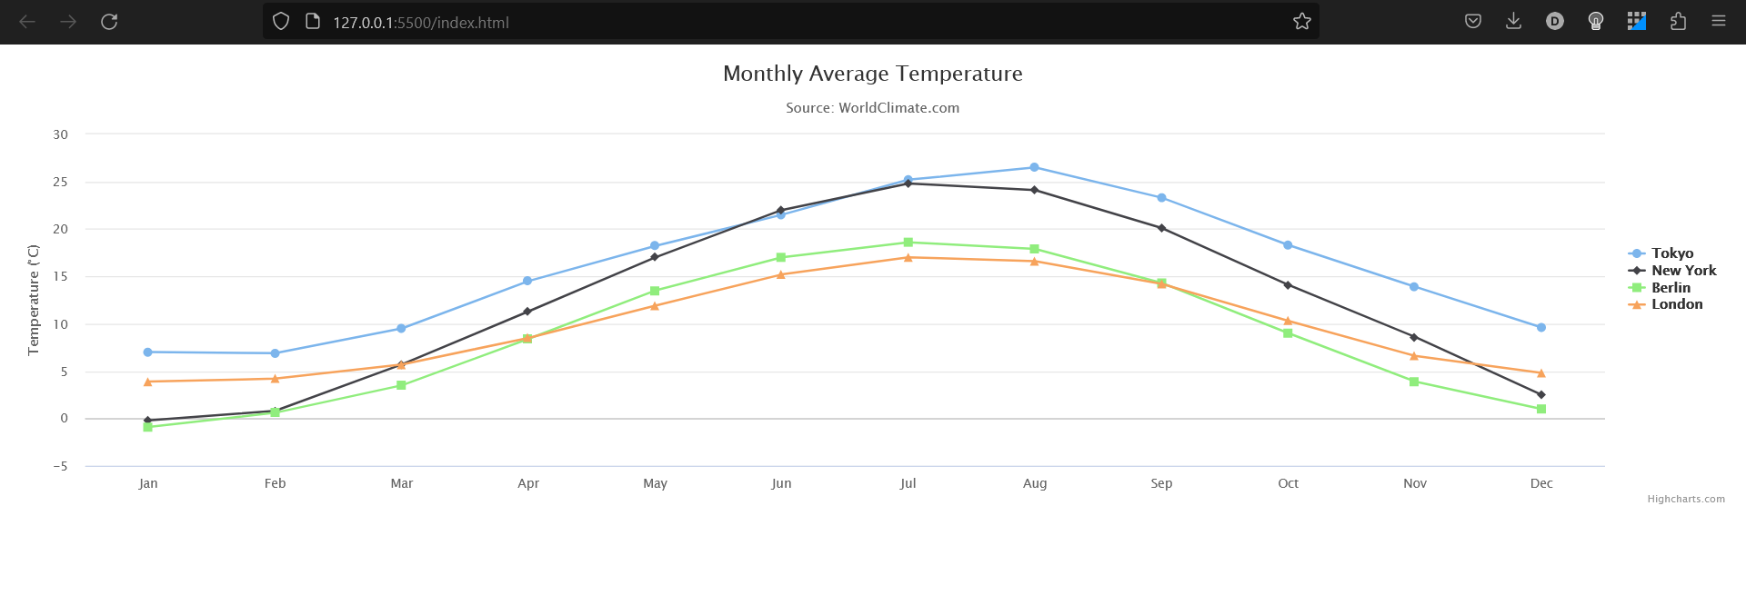

Graph using plotly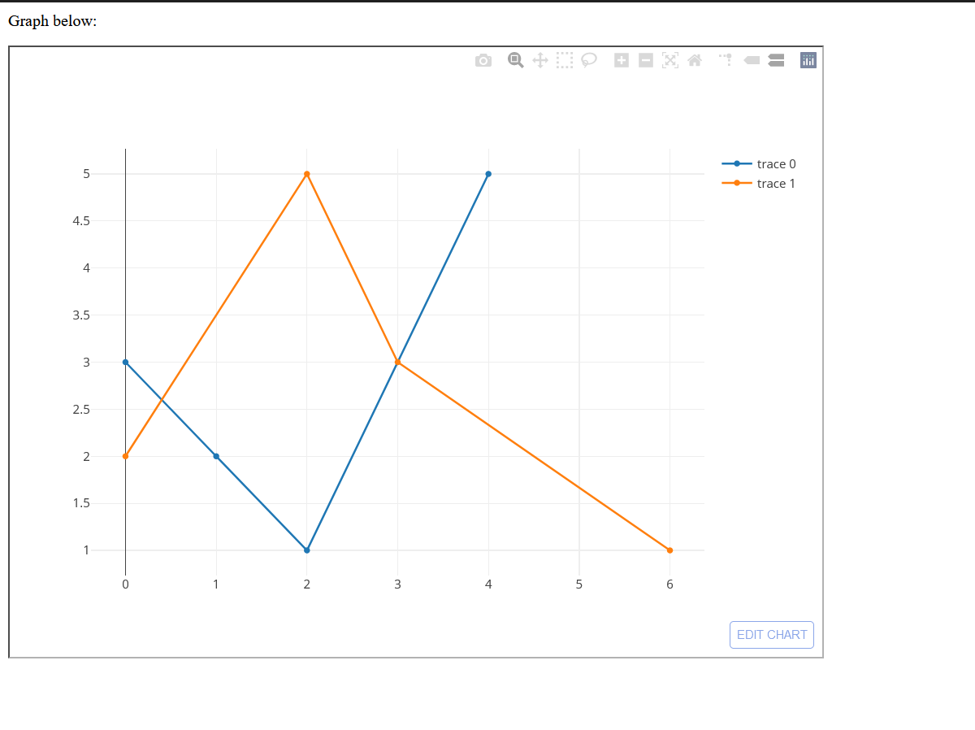

Plotly and Highchart are popular javascript libraries that are used for interactive charts, visualisations in the websites. These both libraries consist of a variety of features and configuring options, but there are multiple major differences in these features hence separating their use case and fields.

Plotly is an open-source library that allows users to create user interactive chart and other visualisations in languages such as JavaScript, Python etc. It offers a variety of chart types such as line, bar, pie charts as well as many complex 3d visualisations for better presentation. Its main features include interactive charts/graphs with which user can zoom, pan and hover over the data graph and obtain additional precise information. It also offers colouring options various fonts, layouts etc.

On the other hand, Highchart is a commercial Javascript library that provide a range of customisable chart types. The features offered by its are identical to that of plotly, including ability to create interactive charts, but it is primarily designed for creating charts in JavaScript. Highcharts offers a range of chart types, including line charts, area charts, bar charts, and pie charts, as well as more advanced visualizations like gauges and funnel charts. Additionally, It also provides responsive charts and other visualisations unlike plotly hence improving the overall UI/UX.

Among these graph plotting libraries, the Highcharts is easy to use and beginner and advanced user friendly because of its well documentation and other provided templates and examples. Also its, responsiveness makes it one of the most demanding library in data visualisation websites.

Also, Highcharts is a commercially licenced as compared to plotly which is open-source and also provides users options of using its paid or free versions depending on their choices. It also offers a range of premium features, such as access to technical support and the ability to export charts in PDF format, which are not available in the free version.

In terms of performance, both Plotly and Highcharts are designed to be fast and efficient, but there are some differences in how they handle large datasets. Plotly is designed to work with data sets of any size, but it may be slower to load and render charts with very large data sets. Highcharts, on the other hand, is optimized for handling large data sets, and it uses a technique called data grouping to speed up the rendering of charts with many data points.

In community support, plotly has a large and active community of developers who contribute to the library, provide support on forums, and create additional tools and resources for working with Plotly. Highcharts also has a community of developers, but it is smaller than Plotly's, and there are fewer resources available for working with the library.

Also, Plotly can be integrated with other Python libraries, such as Pandas and NumPy, to easily import and used to manipulate data. While, Highcharthand, can be integrated with other JavaScript libraries, such as Node and React, for more complex web applications.

Furthermore, Plotly is cross platform supported as it is compatible with multiple platforms such as python, R and Javascript. Whereas, Highcharts is solely focussed on Javascript and might require additional tools for the integration processing.

Both libraries have a learning curve, but it may be steeper for Highcharts due to its more complex API and licensing options. Plotly's API, on the other hand, is simpler to work with, and its open-source version makes it more accessible to developers who are just starting out.

Overall, there are multiple libraries capable of covering their flaws such as D3.js, Chart.js, MATLABPlotlib etc, in which each library is popular and is widely used based on the type of field it is deployed in.